**Battleship**

**Created by**

**Tanapon Suwanmanee 6230218921**

**Tanapol Hongfongfah 6230221721**

**2110215 Programing Methodology**

**Semester 1 Year 2020**

**Chulalongkorn University**

**Battleship**

**1.Battleship: 2 player Turn-based Board Game**

1.1 Gameplay

In prepare phase, you and your friend will place the ships of different size and passive skill on the board. You and your friends can’t see ship each other. Next phase, you try to sink the rival ships. You can do only one action, hit 1 time or use skill. After that, your turn is end and your friend attacks you. The first player is who can destroy all enemy ships will win this game.

1.2 Game Component

1.2.1 Game Board

The game board is size 8*8 cells where you place your ship. Each player has one board.

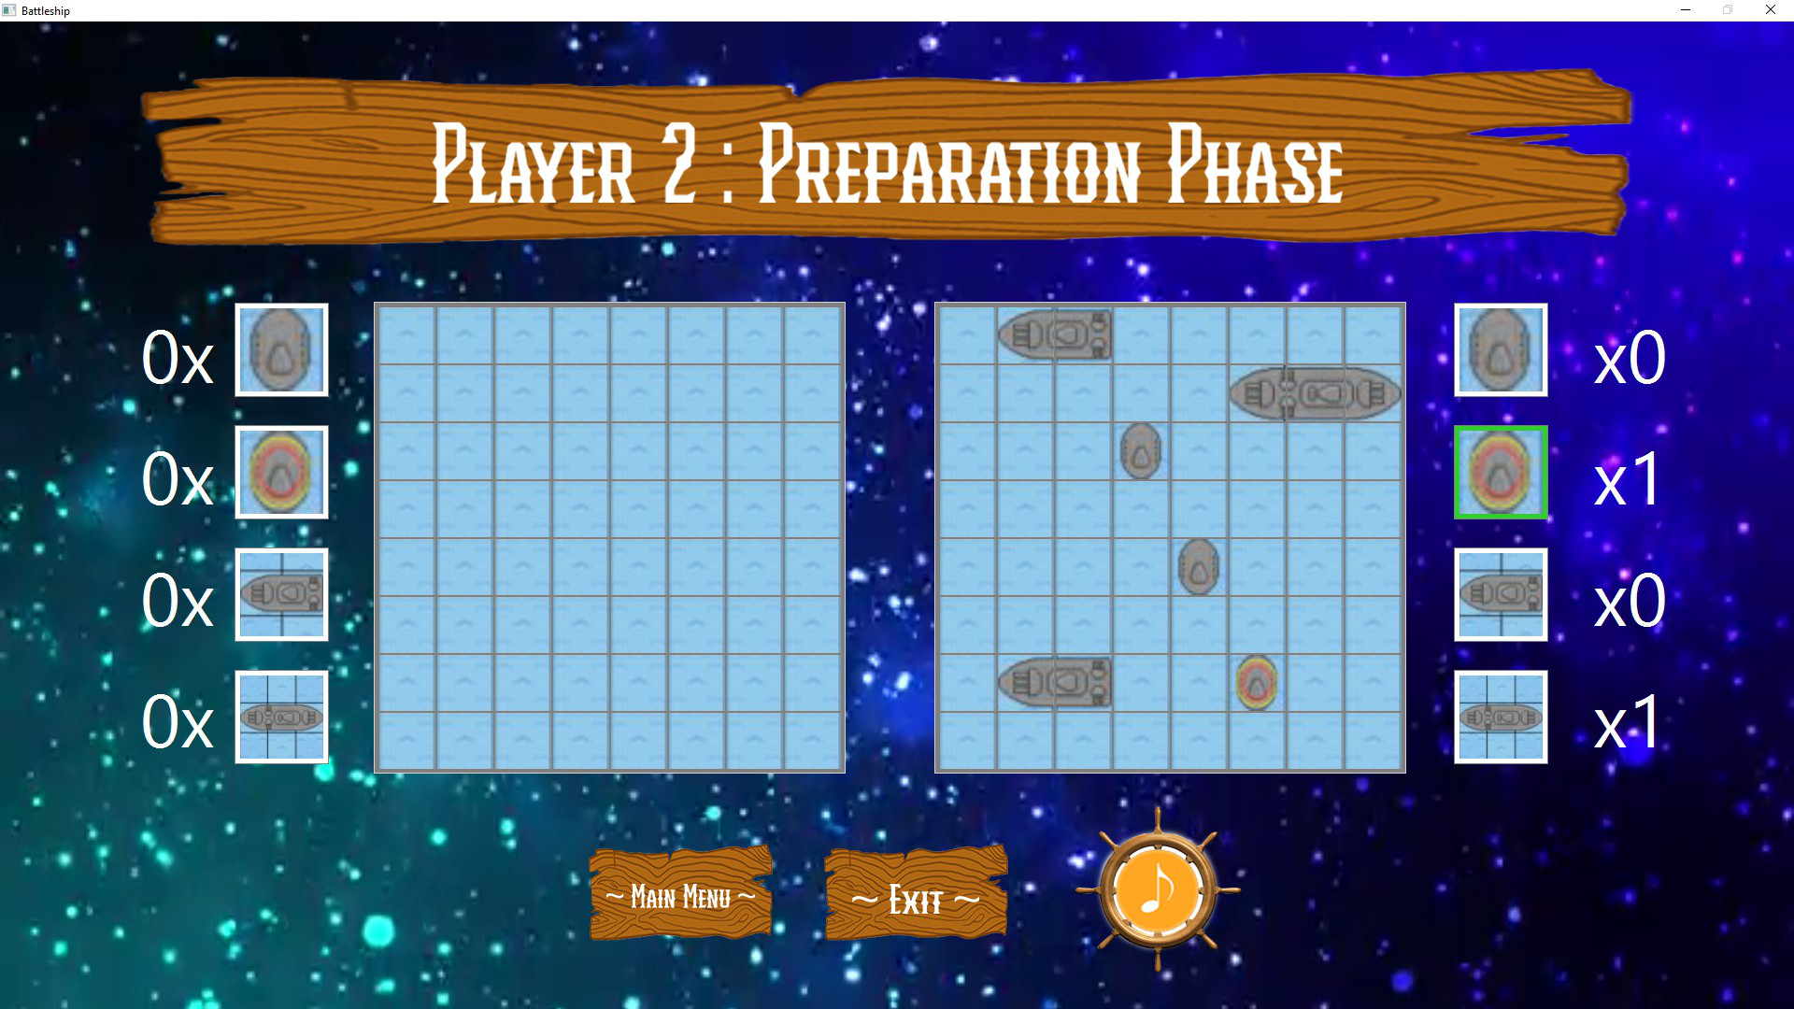

1.2.2 Ship

There are 4 types of ship. You will have 2 ships of each type. Each type of ship has different size and passive skill.

1.2.2.1 Ship01

It is a ship with size 1 cell and passive skill is 33% evasion.



1.2.2.2 Ship02

It is a ship with size 1 cell and passive skill is it has the shield which can protect itself from any attacking 1 time.



1.2.2.3 Ship03

It is a ship with size 2 cells and no passive skill.

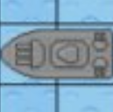

1.2.2.4 Ship04

It is a ship with size 3 cells and no passive skill.

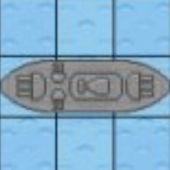

1.2.3 Skill

There are 2 skill for each player. Each Skill can use one time.

1.2.3.1 Horizontal Destroy

Choose one cell in enemy board and then attack all ships in same row.

 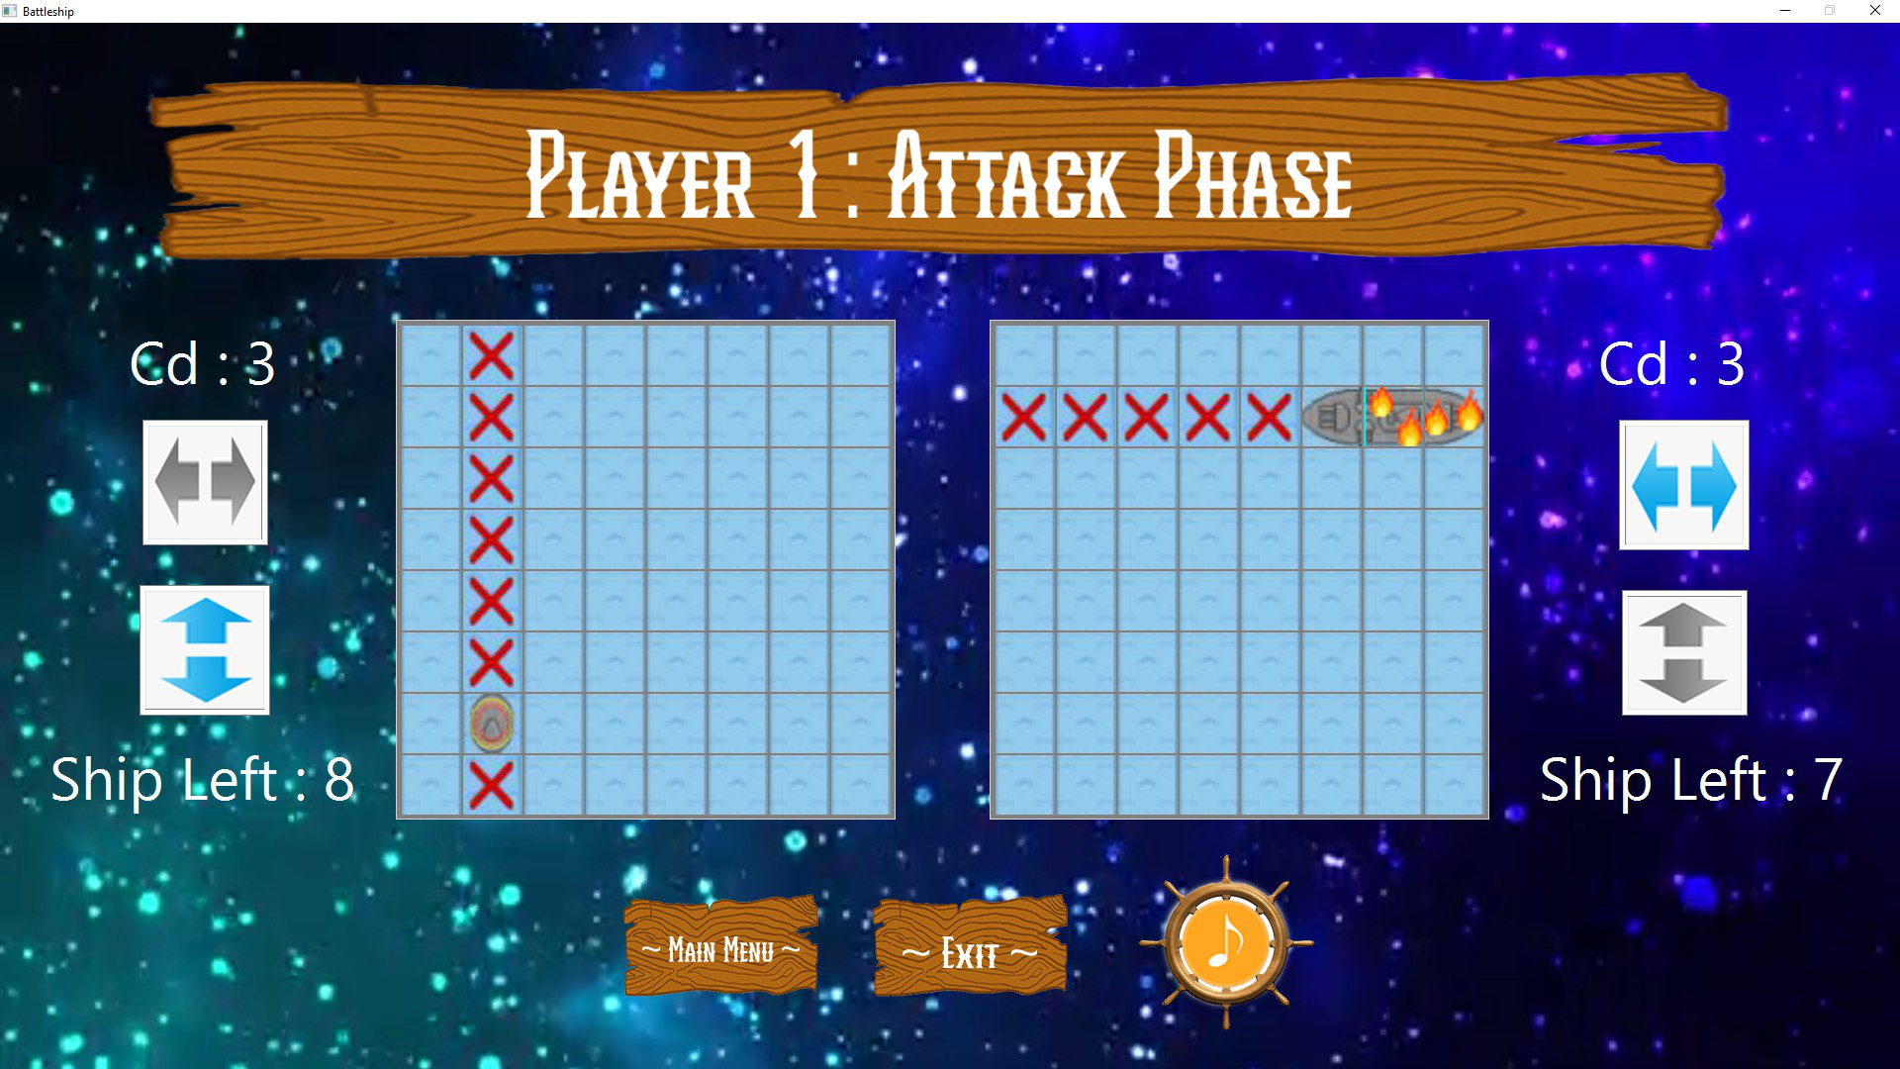

1.2.3.2 Vertical Destroy

Choose one cell in enemy board and then attack all ships in same column.

 

1.3 Game Rule

1.3.1 Ship

- If ship is attacked but it has passive skill to protect itself, it will show on the board

- If ship which has size 2 cells or more is attacked, that part will be destroy and show cross on that cell. You need to attack every part of this ship to destroy it.

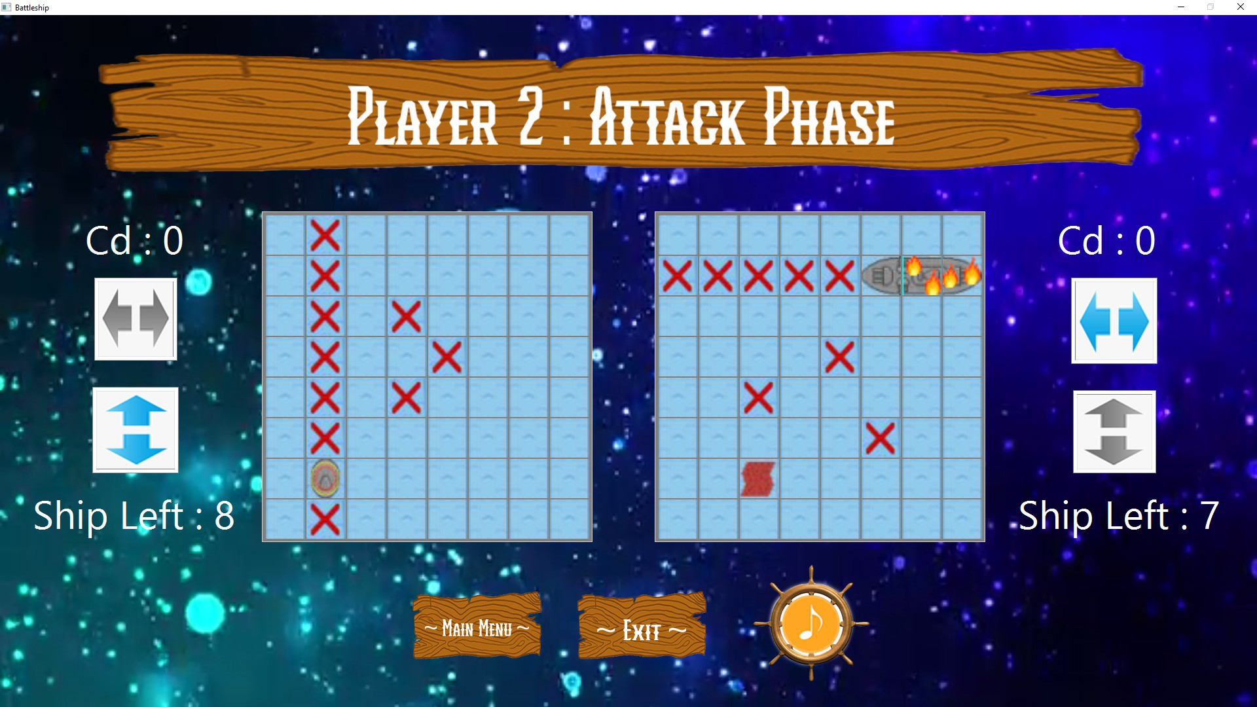 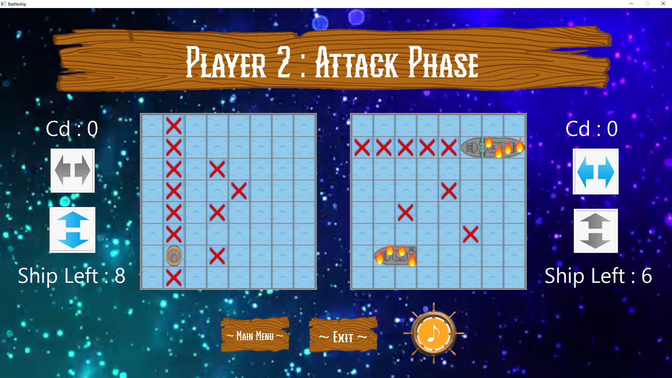

1.3.2 Skill

After using skill, it has cooldown for 3 turns.

1.3.3 Winning condition

Destroy all enemy ships for win this game.

1.4 Game Flow

In prepare phase, player 1 place all ships on own board by choose ship in the ship pane and the click on the field cell. After finish, all ships on the board will hide automatically and player 2 place ships on own board. Then attack phase is start. Player 1 will attack first. Player 1 click on the enemy cell to attack or choose skill in the skill pane and click on the field cell to use skill. After that, next turn Player 2 will attack player 1.

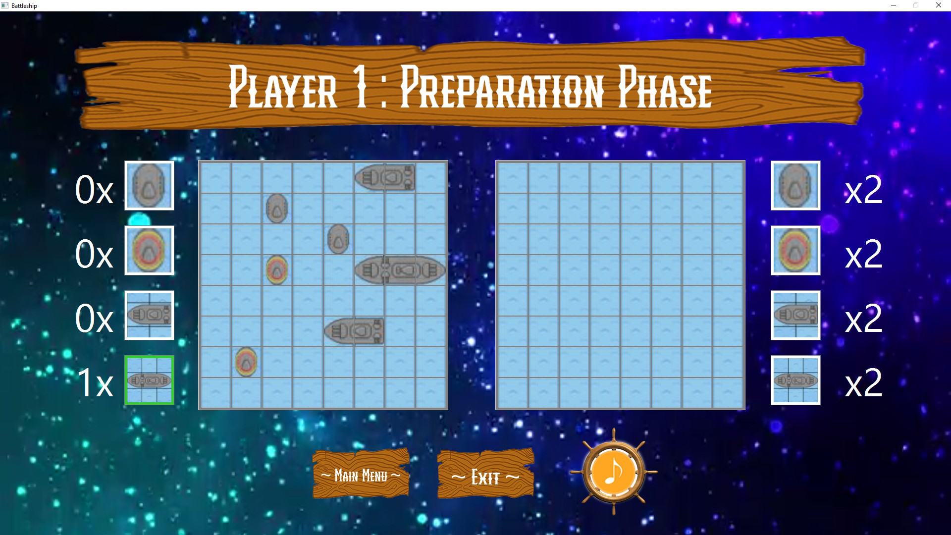





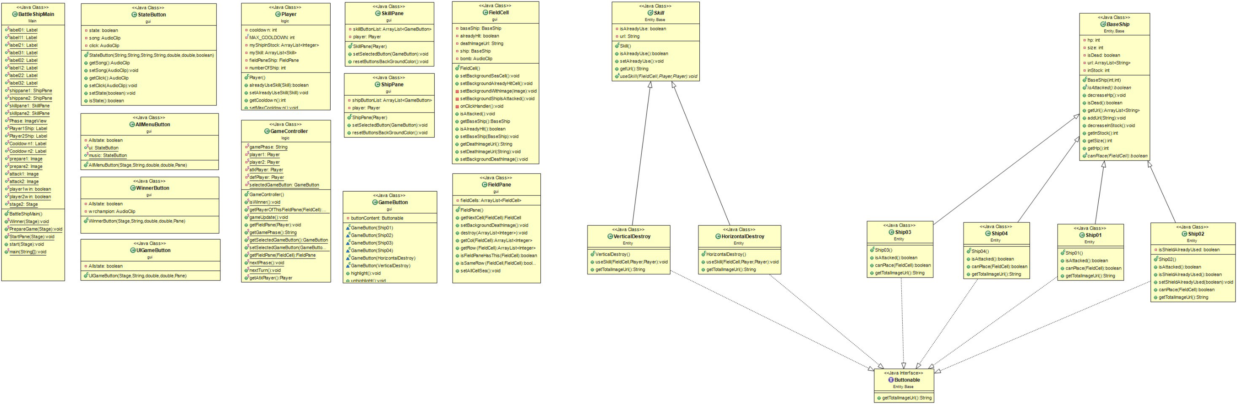**2.Implementation Details:**

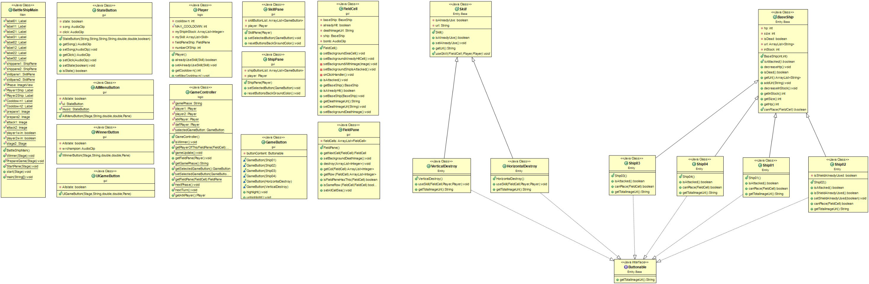

**2.1 Package Entity.Base**

**2.1.1 Abstract Class BaseShip**

**2.1.1.1 Field**

|  |  |
| --- | --- |
| - int hp | Hp of the ship |
| - int size | Size of the ship |
| - int inStock | Amount of ship in the stock |
| - Boolean isDead | Status of the ship |
| - ArrayList<String> url | Url of image of each part of the ship |

**2.1.1.2 Constructor**

|  |  |
| --- | --- |
| + BaseShip(int size, int hp) | Initializes each field according to the parameter. Set isDead to false and inStock with 2. |

**2.1.1.3 Method**

|  |  |
| --- | --- |
| *+ boolean isAttacked()* | Implements by subclass. |
| *+ boolean canPlace (FieldCell fieldCell)* | Implements by subclass. |
| + void decreaseHp() | Decrease hp by 1. If Hp is 0, set isDead to true |
| + void decreseInStock | Decrease inStock by 1. |
| + getter, setter method for each field |  |

**2.1.2 Abstract Class Skill**

**2.1.2.1 Field**

|  |  |
| --- | --- |
| - boolean isAlreadyUse | Status of the skill |
| - String url | Url of Image of the ship |

**2.1.2.2 Constructor**

|  |  |
| --- | --- |
| + Skill() | Initializes isAlreadyUse to false. |

**2.1.2.3 Method**

|  |  |
| --- | --- |
| *- void useSkill(FieldCell fieldCell, Player p1, Player p2)* | Implements by subclass |
| + getter, setter method for each field |  |

**2.1.3 Interface Buttonable**

|  |  |
| --- | --- |
| + String getTotalImageUrl | Return url of image for fill in the button. |

**2.2 Package Entity**

**2.2.1 Class Ship01 extends BaseShip implements Buttonable**

**2.2.1.1 Constructor**

|  |  |
| --- | --- |
| + public Ship01() | Initializes Hp = 1 , size = 1 and set url. |

**2.2.1.2 Method**

|  |  |
| --- | --- |
| + boolean isAttacked() | Ramdom integer from 0 to 2. If the number not equals 0, call method decreaseHp and return true. Otherwise, return false because this attacking is miss. |
| + boolean canPlace(FieldCell fieldCell) | Return true because it can place without condition. |
| + String getTotalImageUrl() | Return url of total image. |

**2.2.2 Class Ship02 extends BaseShip implements Buttonable**

**2.2.2.1 Field**

|  |  |
| --- | --- |
| - boolean isShieldAlreadyUsed | The name of the card. |

**2.2.2.2 Constructor**

|  |  |
| --- | --- |
| + public Ship02() | Initializes Hp = 1 , size = 1, set url and call method setShieldAlreadyUse(false). |

**2.2.2.3 Method**

|  |  |
| --- | --- |
| + boolean isAttacked() | If shieldIsAlreadyUsed, call method dereaseHp and return true. Otherwise, call method setShieldAlreadyUse(true) and return false. Shield can protect itself 1 time. |
| + boolean canPlace(FieldCell fieldCell) | Return true because it can place without condition. |
| + String getTotalImageUrl() | Return url of total image. |
| + getter method for each field |  |

**2.2.3 Class Ship03 extends BaseShip implements Buttonable**

**2.2.3.1 Constructor**

|  |  |
| --- | --- |
| + public Ship03() | Initializes Hp = 2, size = 2 and set url. |

**2.2.3.2 Method**

|  |  |
| --- | --- |
| + boolean isAttacked() | Call method decreaseHp and return true. |
| + boolean canPlace(FieldCell fieldCell) | Return true if the FieldCell next to the right of fieldCell is null and they are in the same row. |
| + String getTotalImageUrl() | Return url of total image. |

**2.2.4 Class Ship04 extends BaseShip implements Buttonable**

**2.2.4.1 Constructor**

|  |  |
| --- | --- |
| + public Ship04() | Initializes Hp = 3, size = 3 and set url. |

**2.2.4.2 Method**

|  |  |
| --- | --- |
| + boolean isAttacked() | Call method decreaseHp and return true. |
| + boolean canPlace(FieldCell fieldCell) | Return true if the 2 FieldCell next to the right of fieldCell is null and they are in the same row. |
| + String getTotalImageUrl() | Return url of total image. |

**2.2.5 Class HorizontalDestroy extends Skill implements Buttonable**

**2.2.5.1 Constructor**

|  |  |
| --- | --- |
| + public HorizontalDestroy() | Call super() |

**2.2.1.2 Method**

|  |  |
| --- | --- |
| + useSkill(FieldCell fieldCell, Player p1, Player p2) | Set cooldown of p1 with max cooldown and attack all FieldCell of FieldPane of p2 which is same row as fieldCell. |
| + getTotalImageUrl() | Return url of total image |

**2.2.6 Class VerticalDestroy extends Skill implements Buttonable**

**2.2.5.1 Constructor**

|  |  |
| --- | --- |
| + public VerticalDestroy() | Call super() |

**2.2.1.2 Method**

|  |  |
| --- | --- |
| + useSkill(FieldCell fieldCell, Player p1, Player p2) | Set cooldown of p1 with max cooldown and attack all FieldCell of FieldPane of p2 which is same column as fieldCell. |
| + getTotalImageUrl() | Return url of total image. |

**2.3 Package logic**

**2.3.1 Class Player**

**2.3.1.1 Field**

|  |  |
| --- | --- |
| - int cooldown | Cooldown of using skill. |
| - final int MAX_COOLDOWN | After use skill it will cooldown for 3 turns. |
| - int numberOfShip | Amount of ship in the FieldPane left. |
| - ArrayList<Integer> myShipInStock | Amount of each type of ship in the stock left. |
| - ArrayList<Skill> mySkill | Skill of the player. |
| - FieldPane fieldPaneShip | FieldPane of the player to place the ships. |

**2.3.1.2 Constructor**

|  |  |
| --- | --- |
| + public Player() | Initializes each field according to the start value of each type. |

**2.3.1.3 Method**

|  |  |
| --- | --- |
| + boolean alreadyUseSkill(Skill) | Return true if this player is already using this skill. |
| + void setAlreadyUseSkill(Skill) | Set this player is already using this skill. |
| + void setMaxCooldown() | Set this player cooldown with max cooldown. |
| + void decreaseCooldown() | Decrease cooldown by 1. |
| + void decreseShip() | Decrease numberOfShip by 1. |
| + int getInStock(BaseShip ship) | Return amount of left ship same type as parameter. |
| + void decreaseInStock(BaseShip ship) | Decrease inStock of ship with same type as parameter. |
| + getter, setter method for each field |  |

**2.3.2 Class GameController**

**2.3.2.1 Field**

|  |  |
| --- | --- |
| - String gamePhase | Phase of the game. |
| - Player player1 | Player of the game. |
| - Player player2 | Player of the game. |
| - Player atkPlayer | Player which places the ship or attack enemy this turn. |
| - Player defPlayer | Player which is attacked this turn. |
| - GameButton selectedGameButton | GameButton which is selected this turn. |

**2.3.2.2 Constructor**

|  |  |
| --- | --- |
| + public GameController() | Initializes each field. Set game phase with “Player 1 : Preparation Phase”. Set atkPlayer with player 1. Set defPlayer with player 2. |

**2.3.2.3 Method**

|  |  |
| --- | --- |
| + void isWinner() | If player 1 or player 2 is win, set game phase to “END” and show the winner. |
| + Player getPlayerOfThisFieldPane(FieldCell fieldCell) | Return Player of this fieldCell. |
| + void gameUpdate() | Update each label on the screen with valid value. Call method setBackGroundDeathImage() by both player to set the ship which is destroyed with destroyed image. |
| + FieldPane getFieldPane(Player player) | Return FieldPane of the Player according to the parameter. |
| + void nextPhase() | If player 1 place all the ships, set phase with “Player 2 : Preparation Phase”, hide all ships on the board and call method nextTurn().  If player 2 place all the ships, set phase with “Player 1 : Attack Phase”, hide all ships on the board and call method nextTurn(). |
| + void nextTurn() | If atkPlayer is player 1, set atkPlayer with player 2 and defPlayer with player 1. Otherwise, set atkPlayer with player 1 and defPlayer with player 2. |
| + boolean isPrepareFinish(Player Player) | Return true if this player no ship in stock left. |
| + void setGamePhase() | Set game phase according to the atkPlayer. |

**2.4 Package gui**

**2.4.1 Class UIGameButton extends ImageView**

**2.4.1.1 Field**

|  |  |
| --- | --- |
| - boolean Allstate | Status of setting button |

**2.4.1.2 Constructor**

|  |  |
| --- | --- |
| + UIGameButton(Stage stage, String allImage, double x, double y, Pane root) | Initializes each field according to the parameter  Initializes StateButton, btnBack and btnExit. Set the setOnMouseClicked(). |

**2.4.2 Class AllMenuButton extends ImageView**

**2.4.2.1 Field**

|  |  |
| --- | --- |
| - boolean Allstate | Status of button |
| + StateButton ui | Button for turn on/off ui |
| + StateButton music | Button for turn on/off music |

**2.4.2.2 Constructor**

|  |  |
| --- | --- |
| + AllMenuButton(Stage stage, String allImage, double x, double y, Pane root) | Initializes each field according to the parameter  Initializes StateButton, btnBack and btnExit. Set the setOnMouseClicked(). |

**2.4.3 Class FieldCell extends Pane**

**2.4.3.1 Field**

|  |  |
| --- | --- |
| - String deathImageUrl | Url of image of destroyed ship |
| - boolean alreadyHit | Status of this ship |
| - BaseShip baseShip | Ship on this cell |
| - AudioClip bomb | Bomb sound |

**2.4.3.2 Constructor**

|  |  |
| --- | --- |
| + FieldCell() | Set prefWidth and PrefHeigth with 60. Set minWidth and min Height with 60. Set padding with 5. Call setBackgroundSeaCell(). Add event handler mouse click with onClickHandler(). |

**2.4.3.3 Method**

|  |  |
| --- | --- |
| + void setBackgrounSeaCell() | Set this cell background with sea image. |
| + void setBackgroundAlreadyHitCell() | Set this cell background with cross image |
| - void setBackgroundWithImage (Image image) | Set this cell background with image according to the parameter. |
| - void setBackgroundShipIsAttacked() | Set this cell background with image. |
| - void setBackgroundDeathImage() | Set this cell background with deathImageUrl. |
| - void onClickHandler() | In prepare phase, choose to ship from ShipPane and click on FieldCell to place.  In Attack phase, click on the FieldCell to attack or choose skill from SkillPane and click on the FieldCell to use Skill. |
| - void isAttacked() | If this cell has no ship, call method setBackgroundAlreadyHitCell() and set alreadyHit with true. If this cell has ship, call method isAttacked. If the method return true, it is mean ship is attacked. Then call setBackgroundShipIsAttacked() and set alredyHit with true. If this ship is destroyed decrease the ship of this player. If this method return false, it is mean attacking is miss. Then set this cell background with ship image. |
| - getter, setter method for each field |  |

**2.4.4 Class FieldPane extends GridPane**

**2.4.4.1 Field**

|  |  |
| --- | --- |
| - ArrayList<FieldCell> fieldCells | All FieldCell in this FieldPane |

**2.4.4.2 Constructor**

|  |  |
| --- | --- |
| + FieldPane() | Initializes 64 FieldCells with 8 rows and 8 columns. |

**2.4.4.3 Method**

|  |  |
| --- | --- |
| + FieldCell getNextCell(FieldCell fieldCell) | Get FieldCell next to the right of fieldCell |
| + void setBackGroundDeathImage() | Set all cell with death image. |
| + ArrayList<Integer> getCol(FieldCell fieldCell) | Get index of FieldCell with same column of the filedCell |
| + ArrayList<Integer> getRow(FieldCell fieldCell) | Get index of FieldCell with same row of the filedCell |
| + void destroy(ArrayList<Integer> row) | For each FieldCell according to the parameter call method isAttacked. |
| + boolean isFieldPaneHasThis(FieldCell fieldCell) | Return true if this FieldPane has this fieldCell. |
| + boolean isSameRow(FieldCell f1, FieldCell f2) | Return true if these 2 FieldCell are in the same row. |
| + void setAllCellSea() | For each cell in this FieldPane call setBackgroundSeaCell. |

**2.4.5 Class GameButton extends Button**

**2.4.5.1 Field**

|  |  |
| --- | --- |
| - Buttonable buttonContent | Ship or Skill |

**2.4.5.2 Constructor**

|  |  |
| --- | --- |
| + GameButton(Ship01 ship) | Initializes each field according to parameter. |
| + GameButton(Ship02 ship) | Initializes each field according to parameter. |
| + GameButton(Ship03 ship) | Initializes each field according to parameter. |
| + GameButton(Ship04 ship) | Initializes each field according to parameter. |
| + GameButton (HorizontalDestroy skill) | Initializes each field according to parameter. |
| + GameButton (VerticalDestroy skill) | Initializes each field according to parameter. |

**2.4.5.3 Method**

|  |  |
| --- | --- |
| + void highlight | Set background with Color.LIMEGREEN |
| + void unhighlight | Set background with Color.WHITE |
| + getter method for field |  |

**2.4.6 Class ShipPane extends VBox**

**2.4.6.1 Field**

|  |  |
| --- | --- |
| - ArrayList<GameButton> shipButtonList | All GameButton in ShipPane |
| - Player player | Player of this ShipPane |

**2.4.6.2 Constructor**

|  |  |
| --- | --- |
| + ShipPane(Player player) | Initializes every type of ship, add to shipButtonList and setOnAction by mouse click. |

**2.4.6.3 Method**

|  |  |
| --- | --- |
| + void setSelectedButton (GameButton gameButton) | Set selectedButton to the GameButton which is selected. Call method resetButtonsBackgroundColor() and highlight the selectedButton. |
| + void resetButtonsBackgroundColor() | Unhighlight all button in ShipPane. |

**2.4.7 Class SkillPane extends VBox**

**2.4.7.1 Field**

|  |  |
| --- | --- |
| - ArrayList<GameButton> skillButtonList | All GameButton in SkillPane |
| - Player player | Player of this SkillPane |

**2.4.7.2 Constructor**

|  |  |
| --- | --- |
| + SkillPane(Player player) | Initializes every type of skill, add to skillButtonList and setOnAction by mouse click. |

**2.4.7.3 Method**

|  |  |
| --- | --- |
| + void setSelectedButton (GameButton gameButton) | Set selectedButton to the GameButton which is selected. Call method resetButtonsBackgroundColor() and highlight the selectedButton. |
| + void resetButtonsBackgroundColor() | Unhighlight all button in ShipPane. |

**2.4.8 Class StateButton extends ImageView**

**2.4.8.1 Field**

|  |  |
| --- | --- |
| - boolean state | Status of this StateButton |
| - AudioClip song | Background song |
| - AudioClip click | Sound when click |

**2.4.8.2 Constructor**

|  |  |
| --- | --- |
| + StateButton(String image, String highlightimage, String offimage , String highlightoffimage , double X,double Y , boolean State) | Initializes each field according to parameter.  setOnMouseEnter to set the button highlight. |

**2.4.8.3 Method**

|  |  |
| --- | --- |
| + getter, setter method for each field |  |

**2.5 Package Main**

**2.5.1 Class BattleShipMain extends Application**

**2.5.1.1 Field**

|  |  |
| --- | --- |
| + Label label01 | Label of amount of Ship01 left of Player 1 |
| + Label label11 | Label of amount of Ship02 left of Player 1 |
| + Label label21 | Label of amount of Ship03 left of Player 1 |
| + Label label31 | Label of amount of Ship04 left of Player 1 |
| + Label label02 | Label of amount of Ship01 left of Player 2 |
| + Label label12 | Label of amount of Ship02 left of Player 2 |
| + Label label22 | Label of amount of Ship03 left of Player 2 |
| + Label label32 | Label of amount of Ship04 left of Player 2 |
| + Label Player1Ship | Label of amount of ship on the field left of Player 1 |
| + Label Player2Ship | Label of amount of ship on the field left of Player 2 |
| + Label Cooldown1 | Label of cooldown of Player 1 |
| + Label Cooldown2 | Label of cooldown of Player 2 |
| + Image prepare1 | Image of game phase |
| + Image prepare2 | Image of game phase |
| + Image attack1 | Image of game phase |
| + Image attack2 | Image of game phase |
| + ImageView phase | ImageView of game phase |
| + ShipPane shippane1 | ShipPane of Player 1 |
| + ShipPane shippane2 | ShipPane of Player 2 |
| + SkillPane skillpane1 | SkillPane of Player 1 |
| + SkillPane skillpane2 | SkillPane of Player 2 |

**2.5.1.2 Method**

|  |  |
| --- | --- |
| + void PrepareGame(Stage stage) | Set new pane (named PreparePane) with size (1920,1080).  Initializes each field, set position and add to PreparePane. |
| + void StartPane(Stage stage) | Set scene as new scene with startingGame pane and size (1920,1080).  Set FullScreen with true. |
| + void start(Stage stage) | Generate startingGame pane as new pane.  Set background of startingGame pane.  Set scene as new scene with startingGame pane and size (1920,1080).  Set title with “Battleship”.  Set scene of stage with scene.  Show the stage, sizeToScene and setFullScreen with true. |
| + void main(String[]) | Launch the program |

**2.6 Package Exception**

**2.6.1 Class NoShipSelectedException extends Exception**

**2.4.1.1 Field**

|  |  |
| --- | --- |
| + SkillPane skillpane2 | SkillPane of Player 2 |